SQL Queries Used in Pizza Sales Project:

* *KPI’s Requirement:*

1. Total Revenue

select sum(total_price) as revenue from pizza_sales;

*Output:*

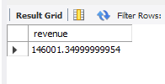

1. Average Order Value

select sum(total_price) / count( distinct order_id) from pizza_sales;

*Output:*

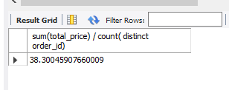

1. Total Pizzas Sold

select sum(quantity) as total_pizza_sold from pizza_sales;

*Output:*

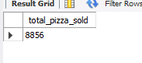

1. Total Orders

select count(distinct order_id) as total_orders from pizza_sales;

*Output:*

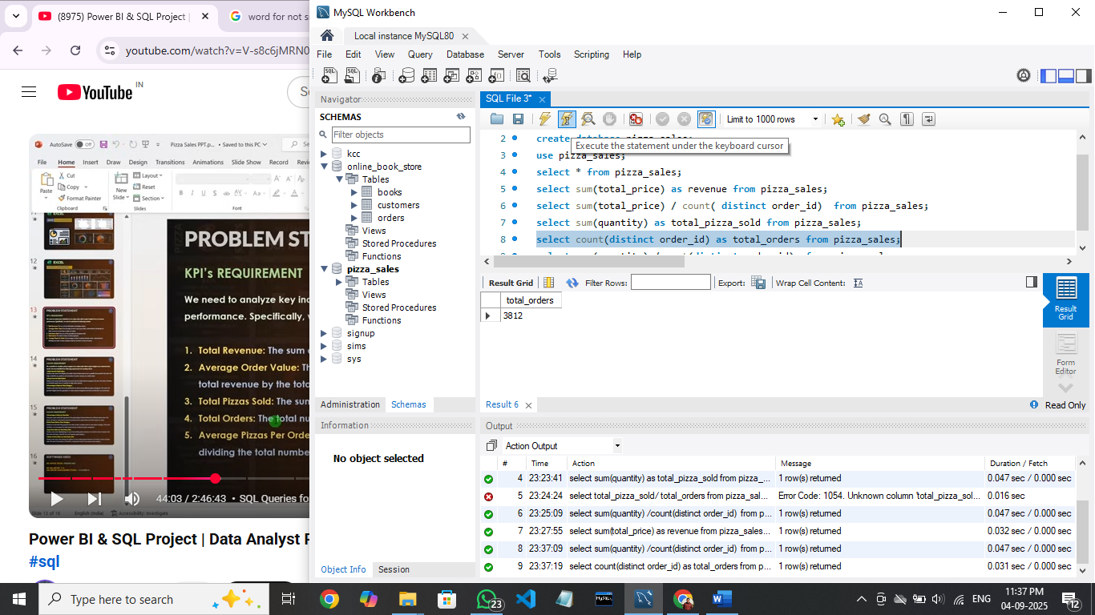

1. Average Pizzas per Order

select sum(quantity) /count(distinct order_id) from pizza_sales;

*Output:*

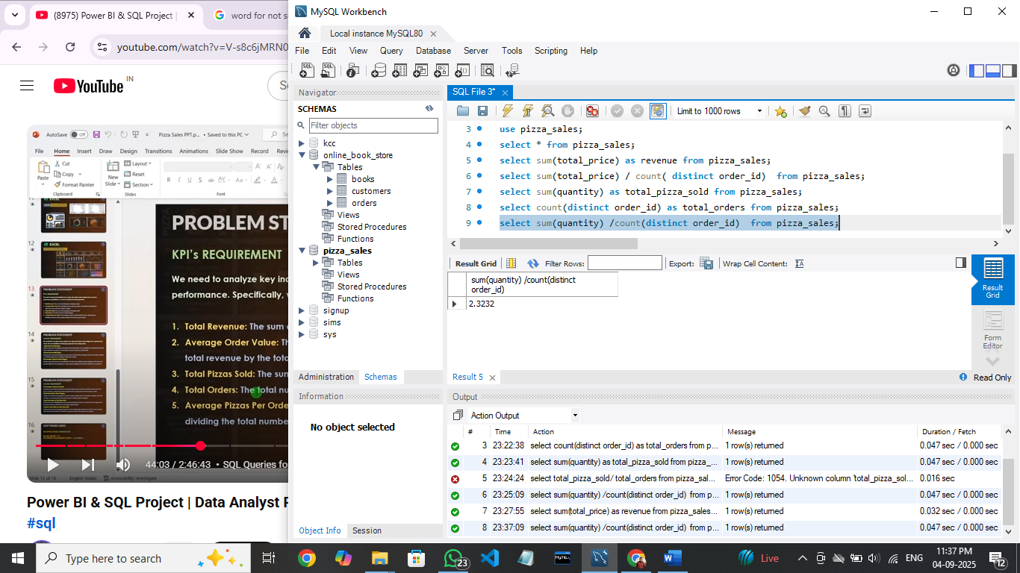

* *Charts Requirement:*

1. Total pizzas Sold by Pizza Category

select pizza_category , sum(quantity) as total_pizza_sold

from pizza_sales

group by pizza_category;

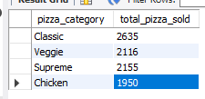

1. Percentage of Sales by Pizza Category

select pizza_category , sum(total_price) *100 /(select sum(total_price) from pizza_sales) as sales_percentage

from pizza_sales group by pizza_category;

*Output:*

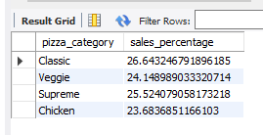

1. Percentage of Sales by Pizza Size

select pizza_size, sum(total_price)*100 /(select sum(total_price) from pizza_sales)

as total_sales

from pizza_sales group by pizza_size;

*Output:*

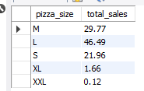

Or

select pizza_size, cast(sum(total_price)*100 / (select sum(total_price) from pizza_sales)

as decimal(10,2))

as total_sales

from pizza_sales group by pizza_size;

#using cast decimal to get result upto 2 decimal places

1. Top 5 best Sellers by Revenue

select pizza_name, sum(total_price) as revenue

from pizza_sales group by pizza_name

order by revenue desc limit 5 ;

*Output:*

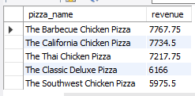

1. Bottom 5 best Sellers by Revenue

select pizza_name, sum(total_price) as revenue

from pizza_sales group by pizza_name

order by revenue asc limit 5 ;

*Output:*

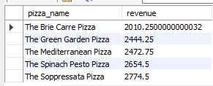

11.Top 5 best Sellers by Total Quantity

select pizza_name, sum(quantity) as total_quantity

from pizza_sales group by pizza_name

order by total_quantity desc limit 5 ;

*Output:*

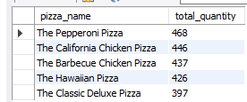

12. Bottom 5 best Sellers by Total Quantity

select pizza_name, sum(quantity) as total_quantity

from pizza_sales group by pizza_name

order by total_quantity asc limit 5 ;

*Output:*

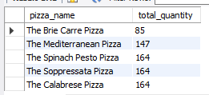

13. Top 5 best Sellers by Total Order

select pizza_name, count(distinct order_id) as total_orders

from pizza_sales group by pizza_name

order by total_orders desc limit 5 ;

*Output:*

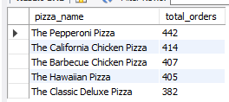

14. Bottom 5 best Sellers by Total Orders

select pizza_name, count(distinct order_id) as total_orders

from pizza_sales group by pizza_name

order by total_orders asc limit 5 ;

*Output:*

